Neighborhood News
Our goal as your HOA Board is to provide transparency with all residents, be the voice of the community and uphold the aesthetics of Heron Isles. We hope with the addition of a monthly newsletter it will increase communication and we look forward to hearing from you on topics you wish to see discussed. Please reach out to any board member to offer your suggestion(s)!
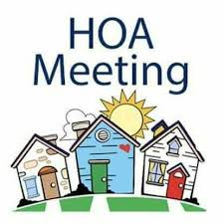
Meeting Notices:
Board Member Meeting
Thursday, March 5th
6:30pm – Junior’s Seafood

Community Events:
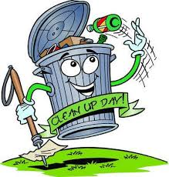
- Community Clean-up – March 14th at 9am
*Please meet at the park
*HOA will provide: gloves, trash bags and water
- Spring Fling – April 18th

Community Safety:
Bicycle safety is always important but as we approach the warmer months kids and adults alike will be out enjoying the weather. As always, be aware of your surroundings and speak to your family about bike safety!
Help keep our community safe - remember if you
see something, say something!

Under Construction: Notice of current community “hot topics” that are being discussed by the HOA Board Members/CDD.
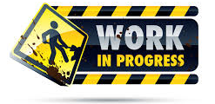
- Swing replacement at the playground
- Replacing mulch at the playground with rubber mulch
- Fence repair/extension (partnering with CDD)

